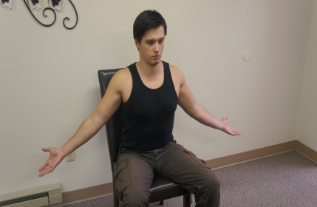
Sitting or standing, reach
behind you with both arms
slightly held away from the
body and rotate palms upwards

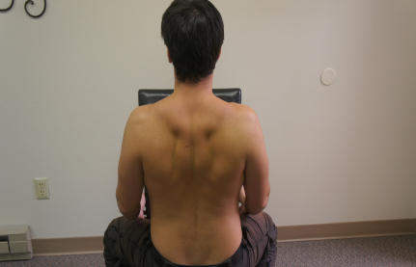
Shrug shoulders up, back
and down. Hold for 3 sec.
Do 6-8 reps or till fatigued
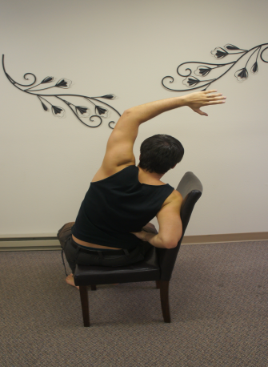
From above position, place LEFT/RIGHT hand
near arm pit. Reach up as high as you can
with the other arm.

